Homework 5

Vismay Gehlot

For this project, I worked my way through the frameworks/API lecture notes which went over Angular js.

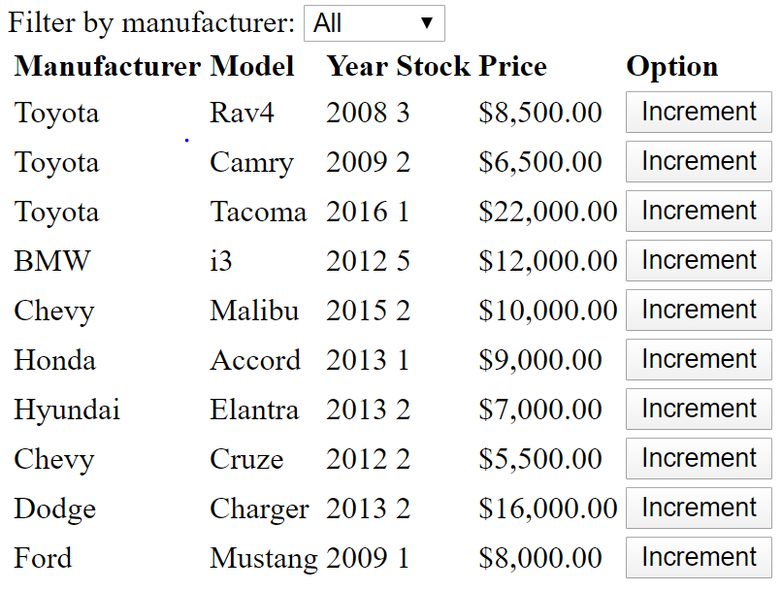

Upon opening up the webpage, this is the default view

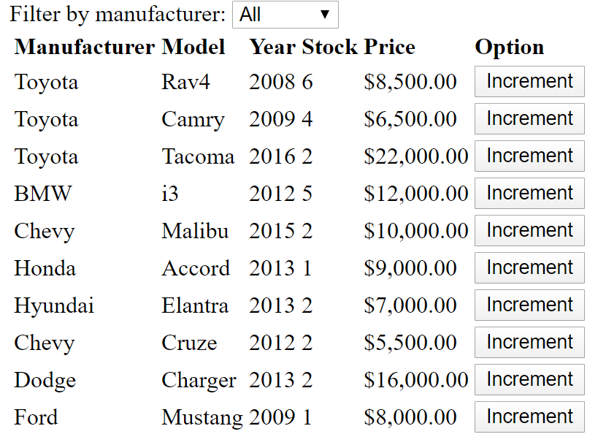

Above, it can be seen that the stock of certain cars has been increased. This was done by using an ngclick tag and incrementing the car.stock.

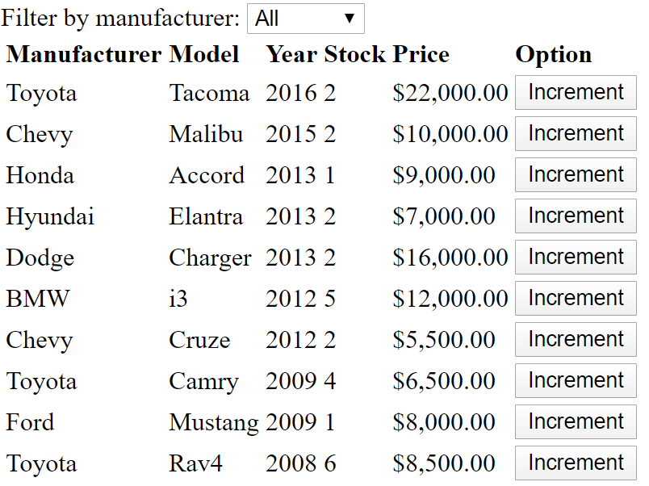

Shown above is the list organized by year. Clicking on the “Year” heading again will organize the list in ascending order. This is accomplished by using another ng click tag and changing $scope.orderByYear().

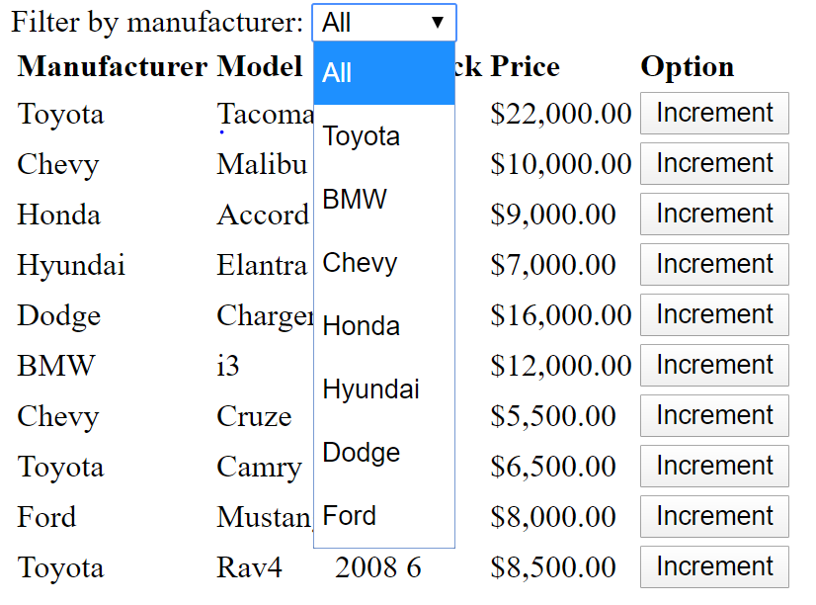

This is the dropdown menu for all the different brands of cars. This is created by using ng options and giving all available manufacturer names. I also used an ng model to set a variable with the selected value, then ran a for loop in the controller and iterating through each car, ordering them respective to manufacturer. Selecting a specific brand yields the results below.

